**Project outline: -**

Company Lockers Pvt. Ltd. is looking for command line java application (desktop application prototype) to manage their file on given drive. Java concepts being used in the project. Data Structures where sorting and searching techniques are used. Option to close the current context and exit from application.

**Product’s capabilities: -**

1. Display all Files, Folders (In Ascending Order).
2. Business-level operations:
3. Add a new file in given project Files Path.
4. Delete a file.
5. Search a file.
6. Exit from business level operations.
7. Exit from application.

**Appearance**: - Windows command line operations, from standard keyboard input.

**Input screen: -**

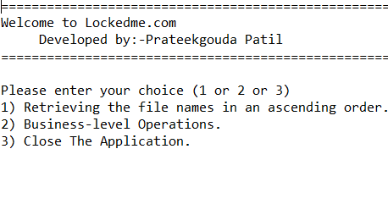

**Output screen 1: -**

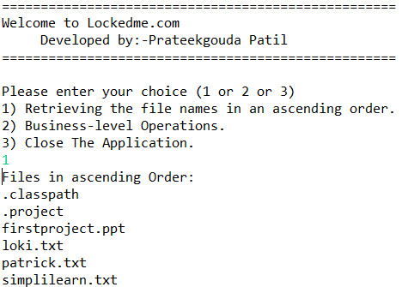

**Output screen 2: -**

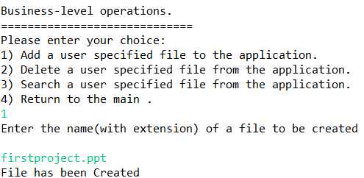

**Output screen 3: -**

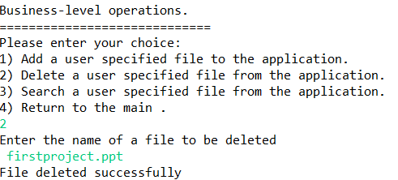

**Output screen 4: -**

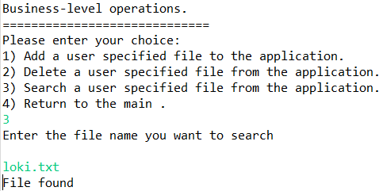

**Output screen 5: -**

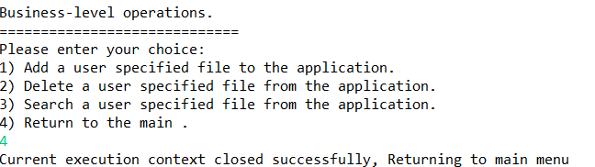

**Output screen 6: -**

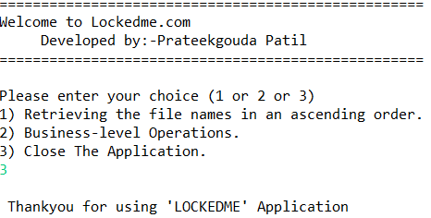

**Development model:**

we have used Agile Project Management approach, with 2 sprints.The duration of each sprint is (1 weeks). The total delivery time would be (2 weeks).

**Source code management and version control: - As agreed we use (**Set up) Git and GitHub account to store and track enhancements of the prototype. The link will be shared as per MOS.

**User interactions: -** Single user, command line interface with no GUI.

**The flow and features of the application:**

**Flow chart (HLD): -**

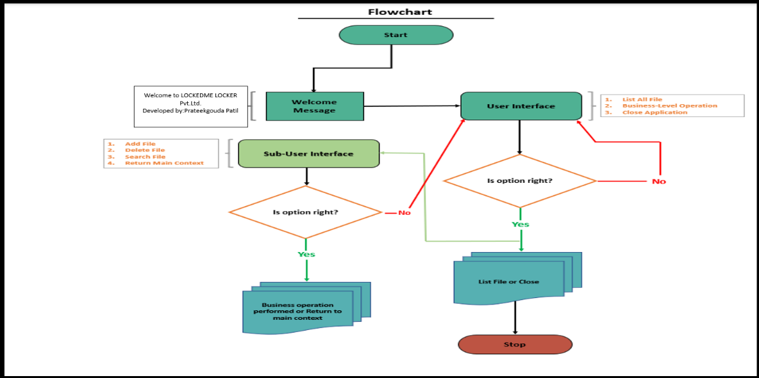

**Features of the application:**

List all file from the existing directory list.

Add a file to the existing directory list.

Delete a user specified file from the existing directory list.

Return a message if FNF (File not found)

Search a user specified file from the main directory.